Penn State University

Great Valley Campus

Engineering Division

Data Specification for Large-Scale Databases to Analyze Election Campaign Contributions

Version 1.0

Adithya Vinod – [avv5502@psu.edu](mailto:avv5502@psu.edu)

03-31-2023

**Table of Contents**

Introduction 3

Purpose 3

Project Summary 3

Requirements Definition 4

Considerations 5

Document Change Log 5

2. Architecture Design 6

2.1 Relational Data Warehouse 6

Steps in Developing a Data Warehouse: 6

1. Select the Business Process 6

2. Declare the Grain 6

3. Identify the Dimensions 7

4. Identify the Facts 10

Data Dictionary 10

Tables schemas 12

2.2 Hadoop Implementation 16

2.3 Reflective analysis of using a data warehouse vs Hadoop. 18

3. Data Preparation 19

3.1 Relational Data Warehouse Implementation 19

ETL considerations 19

3.2 Hadoop Implementation 27

1. Move Data from Local to Docker 27

2. PIG file to Transform Data 28

3. Save Data to HDFS 29

3.3 Reflective analysis of data preparation in relational data warehouse vs Hadoop. 30

4. Reporting System 31

4.1 Relational Data Warehouse Implementation 31

4.2 Hadoop Implementation 34

4.3 Reflective analysis of result in relational data warehouse vs Hadoop. 37

Conclusions 38

Large Scale Database to Analyze Election Contribution Over Time  
  
Adithya Vinod

# Introduction

The analysis of political campaign contributions is a critical component in understanding the dynamics of political campaigns and the funding sources behind them. One of the primary challenges of analyzing political contributions is the sheer volume of data generated over time. To effectively manage and analyze this data, a data warehouse project is required.

The project will involve the consolidation of data from the Federal Election Commission (FEC) filing websites, into a centralized data warehouse. With this data, analytical queries can performed to examine the patterns of contributions over time, identify trends in donor behavior, and assess the impact of various events on the election cycle.

By utilizing data warehousing techniques, data can be effectively stored and large volumes of data can analyzed, providing insights into the funding sources of political campaigns and the impact of contributions on the political process.

# Purpose

The purpose of this project is to effectively implement and compare the two types of large-scale databases: Data Warehouses for dimensional data and Hadoop systems for Distributed data.

# Project Summary

This paragraph is used to introduce the following subsections, which can be used for an executive level overview.

1. **Objectives**

The objective of this project is to build a data warehouse that integrates and organizes people's election contribution data from the Federal Election Commission (FEC) filing website and to find trends on how these contributions have evolved over time using two different database systems: Data Warehouse and Hadoop.

1. **Scope**

Compare the implementation of how data is stored, analyzed, and implemented using two different information systems namely:

* Data Warehouse
* Hadoop

Over the same dataset and same hardware.

1. **References**

[1] [Campaign Financial Institute (http://www.cfinst.org/)](http://www.cfinst.org/)

[2] [OpenSecrets (https://www.opensecrets.org/)](https://www.opensecrets.org/)

[3] [Federal Election Commission (https://www.fec.gov/)](https://www.fec.gov/)

[4] National Institute on Money in Politics (https://www.followthemoney.org/)

[5] ProPublica (https://www.propublica.org/)

1. **Outstanding Issues**
2. Datasets has several missing values.
3. Data discrepancy among amount and aggregated amount columns.
4. Different variations of the same city names.

# Requirements Definition

1. **Goals**

The goals of this project are as follows:

1. Implement two database systems: data warehouse and Hadoop to answer the business questions.
2. Compare the advantages and disadvantages of both systems.
3. Select better system architecture based on specifics of data to be analyzed.
4. **Business Questions**
5. Which Presidential committee received highest donations?
6. What is the state-wise contribution towards the committee “Biden for President”?
7. What is the average contribution by each type of contributor?
8. When can an increase in the amount of money contributed between NY and PA be seen?
9. **Data Requirements**

Data has been provided as part of the project. It consists of several Excel files directly from FEC that consists of financial contribution made towards a political party during election times for three different financial quarters. Data has been pre-processed for the scope of this class, especially it was reduced in size. Files include 28 columns and several groupings for each contributor.

# Considerations

(May include as separate document)

# Document Change Log

|  |  |  |  |  |
| --- | --- | --- | --- | --- |
| **Change Date** | **Version** | **CR #** | **Change Description** | **Author and Organization** |
| 03/31/23 | 1.0 |  | Initial creation. | Adithya Vinod |
| 04/24/23 | 2.0 |  | Project 1 Update | Adithya Vinod |

# 2. Architecture Design

## 2.1 Relational Data Warehouse

### Steps in Developing a Data Warehouse:

### Select the Business Process

The dataset provided consisted of 28 columns of which not all are necessary for the data warehouse implementation. The initial set of columns are as follows:

|  |  |  |  |
| --- | --- | --- | --- |
| filing_id | prefix | employer | tran_id |
| linenumber | suffix | occupation | back_ref_tran_id |
| flag_orgind | address_one | amount | back_ref_sched_name |
| org_name | address_two | date | prigen |
| last_name | city | aggregate_amount | cycle |
| first_name | state | memo_code | fecid |
| middle_name | zip | memo_text | committee_name |

From the above 28, many of the columns are empty and certain attributes regarding name and ids are not relevant for the data warehouse. Because of this, attributes are filtered down to 12 attributes, namely:

|  |  |  |  |
| --- | --- | --- | --- |
| city | flag_orgind | occupation | prigen |
| state | org_name | amount | cycle |
| zip | employer | date | committee_name |

### Declare the Grain

The grain determines the lowest, most atomic data that the data warehouse will capture.

|  |  |
| --- | --- |
| **Fact table** | **Grain** |
| Amount | Date/ Daily grain |

**Attributes in the Dimension Table:**

|  |  |
| --- | --- |
| **Dimension Table** | **Important Attribute** |
| Date Table | day |
| Location Table | city |
| Contributor Table | origin |
| Election Table | committee_name |

### Identify the Dimensions

|  |  |  |
| --- | --- | --- |
| Count | Attribute | Note |
| 1. | filing_id | This is a dimension that I will consider irrelevant in our case because I want to look only at trends and not at predicting individual behavior. |
| 2. | linenumber | This is a dimension that I will consider irrelevant in our case because I want to look only at trends and not at predicting individual behavior. |
| 3. | flag_orgind | This is a good dimension if I want to identify what type of contributor it was. |
| 4. | org_name | This is a good dimension if I want to identify which organization contributed the donation. |
| 5. | last_name | This is a dimension that I will consider irrelevant in our case because I want to look only at trends and not at predicting individual behavior. |
| 6. | first_name | This is a dimension that I will consider irrelevant in our case because I want to look only at trends and not at predicting individual behavior. |
| 7. | middle_name | This is a dimension that I will consider irrelevant in our case because I want to look only at trends and not at predicting individual behavior. |
| 8. | prefix | This is a dimension that I will consider irrelevant in our case because I want to look only at trends and not at predicting individual behavior. |
| 9. | suffix | This is a dimension that I will consider irrelevant in our case because I want to look only at trends and not at predicting individual behavior. |
| 10. | address_one | This is a dimension that I will consider irrelevant in our case because I want to look only at trends and not at predicting individual behavior. |
| 11. | address_two | This is a dimension that I will consider irrelevant in our case because I want to look only at trends and not at predicting individual behavior. |
| 12. | city | This is a good dimension if I want to identify which city the contribution came from. |
| 13. | state | This is a good dimension if I want to identify which state the contribution came from. |
| 14. | zip | This is a good dimension if I want to identify which zip the contribution came from. |
| 15. | employer | This is a good dimension if I want to identify which employer the contributor works for. |
| 16. | occupation | This is a good dimension if I want to identify what the occupation of the contributor is. |
| 17. | amount | This is not a dimension but rather a fact. |
| 18. | date | This is a good dimension that define the grain of the date. |
| 19. | aggregate_amount | This is a fact, but I will be considering using amount instead of aggregate_amount. |
| 20. | memo_code | This is a dimension that I will consider irrelevant in our case because I want to look only at trends and not at predicting individual behavior. |
| 21. | memo_text | This is a dimension that I will consider irrelevant in our case because I want to look only at trends and not at predicting individual behavior. |
| 22. | tran_id | This is a dimension that I will consider irrelevant in our case because I want to look only at trends and not at predicting individual behavior. |
| 23. | back_ref_tran_id | This is a dimension that I will consider irrelevant in our case because I want to look only at trends and not at predicting individual behavior. |
| 24. | back_ref_sched_name | This is a dimension that I will consider irrelevant in our case because I want to look only at trends and not at predicting individual behavior. |
| 25. | prigen | This is a good dimension if I want to identify which type of election the contribution was collected for. |
| 26. | cycle | This is a good dimension if I want to identify which election cycle the contribution was collected for. |
| 27. | fecid | This is a dimension that I will consider irrelevant because I are considering committee name instead, which is more understandable. |
| 28. | committee_name | This is a good dimension if I want to identify which committee the contribution was collected for. |

In conclusion a star schema should be created with eleven dimensions:

* city
* state
* zip
* flag_orgind
* org_name
* employer
* occupation
* date
* prigen
* cycle
* committee_name

For economy of space, only four dimensions will be used:

* Location Dimension
* Election Dimension
* Date Dimension
* Contributor Dimension

For each of these dimensions a table will be created containing an id and a description field.

### Identify the Facts

In this project, it is interesting to understand the various donations towards election campaigns. So, the fact table needs to contain data regarding the amount that is donated along with the count of donations that has taken place on a particular day (the grain specified is daily grain). A long with the amount and count, the ids from the above-mentioned dimension table need to be stored as well.

### Data Dictionary

A Data Dictionary is a document that describes the basic organization of a database. Typically, a data dictionary will contain a list of variables in the database as well as the assigned variable names and a description of each type of variable. The data dictionary should also include the values accepted for each variable and any helpful comment such as important exclusions and skip patterns. The data dictionary is used primarily for data analysis.

|  |  |  |  |  |
| --- | --- | --- | --- | --- |
| **Location Table** | | | | |
| Variable | Variable name | Variable type | Values | notes |
| Location Id number | location_id | Serial | 001-999 |  |
| City | city | String | ABERDEEN, MALVERN, etc. |  |
| State | state | String | PA, NY, NJ |  |
| Zip code | zip | String | 10001- 99999 |  |

|  |  |  |  |  |
| --- | --- | --- | --- | --- |
| **Election Table** | | | | |
| Variable | Variable name | Variable type | Values | notes |
| Election Id number | election_id | Serial | 001-999 |  |
| Election Type | election_type | String | Primary, General |  |
| Election Cycle | cycle | Numeric | 2020, 2021 |  |
| Committee Name | committee_name | String | Bernie 2020, Biden For President, etc. |  |

|  |  |  |  |  |
| --- | --- | --- | --- | --- |
| **Date Table** | | | | |
| Variable | Variable name | Variable type | Values | notes |
| Date Id number | date_id | Serial | 001-999 |  |
| Date | date | Date | 2016-07-29 |  |
| Day of the week | day_of_week | String | Sunday - Saturday |  |
| Month | month | String | January - December |  |
| Week | week | Numeric | 1 - 52 |  |
| Day | day | Numeric | 1 - 31 |  |

|  |  |  |  |  |
| --- | --- | --- | --- | --- |
| **Contributor Table** | | | | |
| Variable | Variable name | Variable type | Values | notes |
| Date Id number | contributor_id | Serial | 001-999 |  |
| Origin | origin | String | CAN, ORG, IND |  |
| Organization name | org_name | String | Fox News, Hilton Hotels, etc. |  |
| Employer | employer | String | Zillow, 7-Eleven, etc. |  |
| Occupation | occupation | String | Engineer, Doctor, etc. |  |

|  |  |  |  |  |
| --- | --- | --- | --- | --- |
| **Facts Table** | | | | |
| Variable | Variable name | Variable type | Values | notes |
| Location Id number | location_id | Numeric | 001-999 |  |
| Election Id number | election_id | Numeric | 001-999 |  |
| Contributor Id number | contributor_id | Numeric | 001-999 |  |
| Date Id number | date_id | Numeric | 001-999 |  |
| Amount | amount | Numeric | 100 |  |
| Count | count | Numeric | 2 |  |

### Tables schemas

Provide a description of the physical schema of the data warehouse. Use the steps in the lesson and explain.

|  |  |  |  |
| --- | --- | --- | --- |
| ***location*** |  |  |  |
| **Description** | This table talks about the various locations. | | |
| **Attribute** | **Description** | **Type** | **Examples of values** |
| **location_id** | Id of a location | Integer | 001-999 |
| **city** | Name of a city | String | ABERDEEN, MALVERN, etc. |
| **state** | Name of a state | String | PA, NY, NJ |
| **zip** | Zip code of a location | String | 10001- 99999 |
| **Primary Key** | **location_id** | | |
| **Foreign Keys** | None | | |
| **Input: SQL code** | -- project."location" definition  -- Drop table  -- DROP TABLE project."location";  **CREATE** **TABLE** project."location" (  location_id serial4 **NOT** **NULL**,  city **varchar** **NOT** **NULL**,  state **varchar** **NOT** **NULL**,  zip **varchar** **NOT** **NULL**,  **CONSTRAINT** location_pk **PRIMARY** **KEY** (location_id)  ); | | |

|  |  |  |  |
| --- | --- | --- | --- |
| ***date*** |  |  |  |
| **Description** | This table talks about the various date’s contribution was collected on. | | |
| **Attribute** | **Description** | **Type** | **Examples of values** |
| **date_id** | Id of a date | Integer | 001-999 |
| **date** | Date of collection | Date | 2016-07-29 |
| **day_of_week** | Day of the week | String | Sunday - Saturday |
| **month** | Month of the week | String | January - December |
| **week** | Week of the year | Integer | 1 - 52 |
| **day** | Day of the year | Integer | 1 - 31 |
| **Primary Key** | **date_id** | | |
| **Foreign Keys** | None | | |
| **Input: SQL code** | -- project."date" definition  -- Drop table  -- DROP TABLE project."date";  **CREATE** **TABLE** project."date" (  date_id serial4 **NOT** **NULL**,  "date" **date** **NOT** **NULL**,  day_of_week **varchar** **NOT** **NULL**,  "month" **varchar** **NOT** **NULL**,  **week** **int4** **NOT** **NULL**,  "day" **int4** **NOT** **NULL**,  **CONSTRAINT** date_pk **PRIMARY** **KEY** (date_id)  ); | | |

|  |  |  |  |
| --- | --- | --- | --- |
| ***election*** |  |  |  |
| **Description** | This table talks about the various candidates and election types. | | |
| **Attribute** | **Description** | **Type** | **Examples of values** |
| **election_id** | Id of an election type | Integer | 001-999 |
| **election_type** | Election Type | String | Primary, General |
| **cycle** | Election Cycle | Integer | 2020, 2021 |
| **committee_name** | Committee Name | String | Bernie 2020, Biden For President, etc. |
| **Primary Key** | **election_id** | | |
| **Foreign Keys** | None | | |
| **Input: SQL code** | -- project.election definition  -- Drop table  -- DROP TABLE project.election;  **CREATE** **TABLE** project.election (  election_id serial4 **NOT** **NULL**,  election_type **varchar** **NOT** **NULL**,  "cycle" **int4** **NOT** **NULL**,  committee_name **varchar** **NOT** **NULL**,  **CONSTRAINT** election_pk **PRIMARY** **KEY** (election_id)  ); | | |

|  |  |  |  |
| --- | --- | --- | --- |
| ***contributors*** |  |  |  |
| **Description** | This table talks about the various contributors towards election campaigns. | | |
| **Attribute** | **Description** | **Type** | **Examples of values** |
| **contributor_id** | Id of a contributor | Integer | 001-999 |
| **origin** | Contributor Type | String | CAN, ORG, IND |
| **org_name** | Contributor Organization | String | Fox News, Hilton Hotels, etc. |
| **employer** | Contributor Employer | String | Zillow, 7-Eleven, etc. |
| **occupation** | Contributor Occupation | String | Engineer, Doctor, etc. |
| **Primary Key** | **contributor_id** | | |
| **Foreign Keys** | None | | |
| **Input: SQL code** | -- project.contributor definition  -- Drop table  -- DROP TABLE project.contributor;  **CREATE** **TABLE** project.contributor (  contributor_id serial4 **NOT** **NULL** **DEFAULT** **nextval**('project.contributors_contributor_id_seq'::**regclass**),  origin **varchar** **NOT** **NULL**,  org_name **varchar** **NULL**,  employer **varchar** **NULL**,  occupation **varchar** **NULL**,  **CONSTRAINT** contributors_pk **PRIMARY** **KEY** (contributor_id)  ); | | |

|  |  |  |  |
| --- | --- | --- | --- |
| ***facts*** |  |  |  |
| **Description** | This table talks about the amount contributed towards election campaign. | | |
| **Attribute** | **Description** | **Type** | **Examples of values** |
| **location_id** | Id of a location | Integer | 001-999 |
| **election_id** | Id of an election | Integer | 001-999 |
| **contributor_id** | Id of a contributor | Integer | 001-999 |
| **date_id** | Id of a date | Integer | 001-999 |
| **amount** | Amount contributed | Numeric | 100 |
| **count** | Number of contributions | Integer | 2 |
| **Primary Key** | **(location_id election_id, contributor_id, date_id)** | | |
| **Foreign Keys** | **location_id, election_id, contributor_id, date_id** | | |
| **Input: SQL code** | -- project.fact definition  -- Drop table  -- DROP TABLE project.fact;  **CREATE** **TABLE** project.fact (  amount **numeric** **NOT** **NULL**,  location_id **int4** **NOT** **NULL**,  election_id **int4** **NOT** **NULL**,  contributor_id **int4** **NOT** **NULL**,  date_id **int4** **NOT** **NULL**,  **count** **int4** **NOT** **NULL**,  **CONSTRAINT** fact_pk **PRIMARY** **KEY** (location_id, election_id, contributor_id, date_id),  **CONSTRAINT** fact_fk **FOREIGN** **KEY** (contributor_id) **REFERENCES** project.contributor(contributor_id),  **CONSTRAINT** fact_fk_1 **FOREIGN** **KEY** (election_id) **REFERENCES** project.election(election_id),  **CONSTRAINT** fact_fk_2 **FOREIGN** **KEY** (location_id) **REFERENCES** project."location"(location_id),  **CONSTRAINT** fact_fk_3 **FOREIGN** **KEY** (date_id) **REFERENCES** project."date"(date_id)  ); | | |

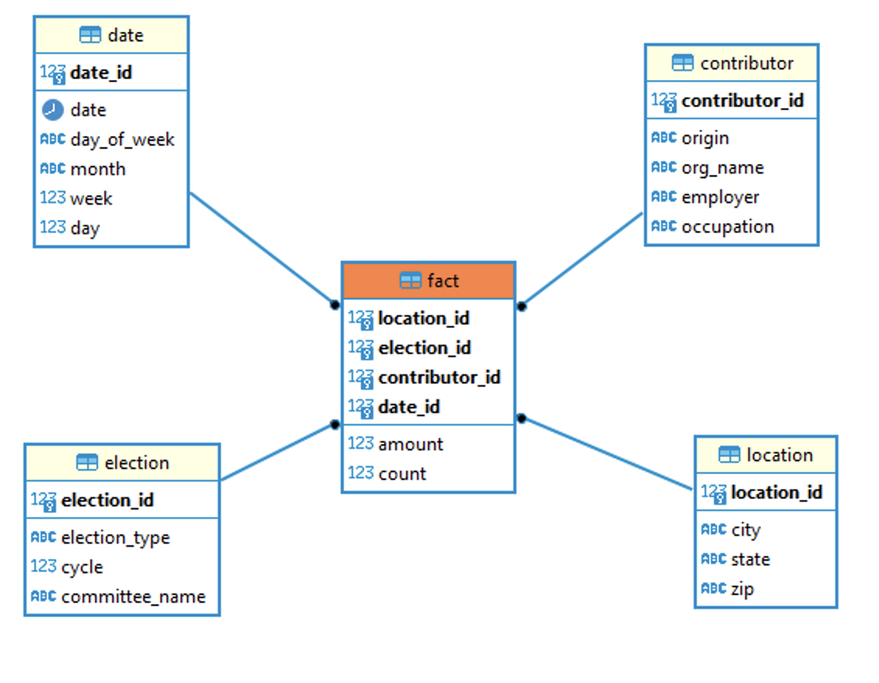

## 2.2 Hadoop Implementation

The Apache Hadoop software is a free and open-source framework that enables the distribution of data storage and processing across a network of computers, using simple programming models. Hadoop can function on a single computer or scale up to thousands of interconnected clusters, where each machine contributes local storage and computation power. In this way, Hadoop can efficiently store and process large datasets ranging in size from gigabytes to petabytes of data.

For performing the Hadoop implementation, we need to create a Hadoop table within a Hadoop database. For this project a database called Project is created and a table called fact is used to store the data. The fact table will consist of 12 columns that will record the details regarding various contributors, location, the committee name and the amount contributed.

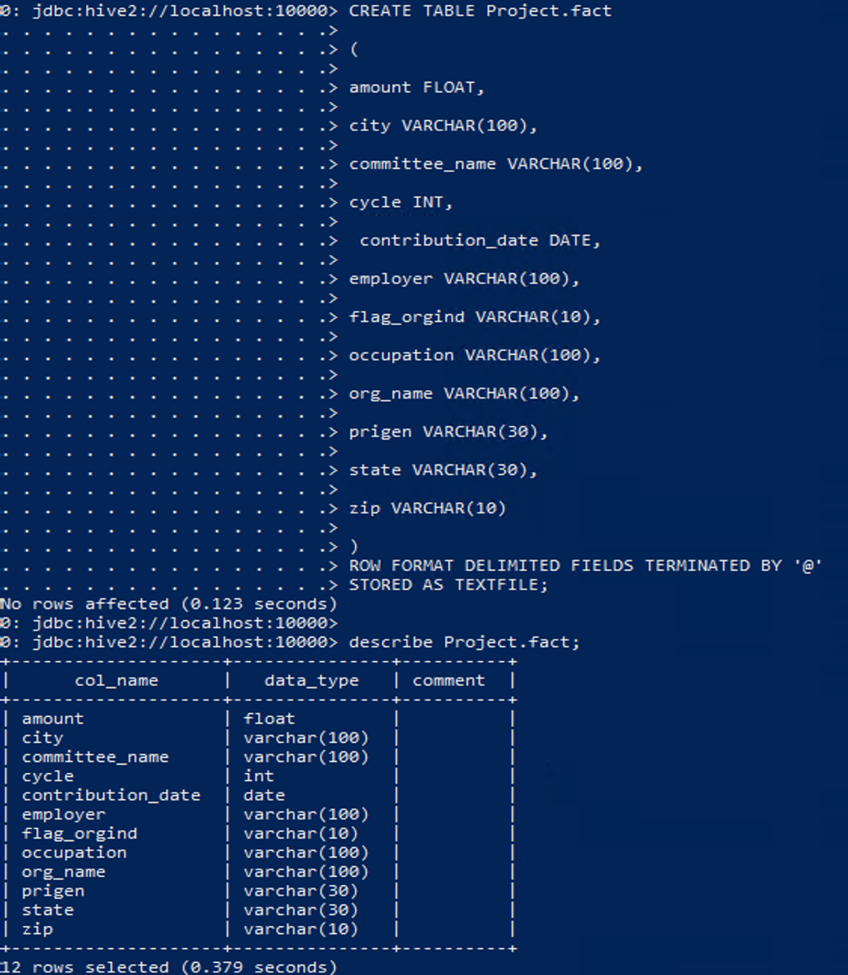

|  |  |  |  |
| --- | --- | --- | --- |
| Table name - fact | | | |
| Columns | Data type | Example | Description |
| amount | float | 100.00 | Amount contributed |
| city | varchar(100) | Malvern | City |
| committee_name | varchar(100) | Biden for President | Committee name |
| cycle | int | 2020 | Election cycle |
| contribution_date | date | 2021-12-03 | Date of contribution |
| employer | varchar(100) | Self, Retired | Name of employer |
| flag_origind | varchar(10) | IND | Contributor type |
| occupation | varchar(100) | Teacher | Occupation |
| org_name | varchar(100) | Microsoft | Organization name |
| prigen | varchar(30) | P2020, G2020 | Election type |
| state | varchar(30) | NY, PA, NJ | State |
| zip | varchar(10) | 19355 | Zip |

## 2.3 Reflective analysis of using a data warehouse vs Hadoop.

**Data Warehouse**

A data warehouse is an organizational structure that ensures data integrity. Usually, data warehouses are implemented using a relational database management system (RDBMS) which serves as the central source for data. The architecture of a data warehouse was designed using DBeaver and implemented using PostgreSQL which is a powerful and open-source RDBMS.

To design a data warehouse, the first step is to identify the business requirements for the data. Based on these requirements, attributes, dimension tables, and fact tables are created. DBeaver is then used to create tables in PostgreSQL to store the identified attributes. The relationship between tables is established using foreign keys.

Once all the tables have been created and the relationships between them have been established, an entity-relationship (ER) diagram is created to depict the data warehouse architecture which follows a Star Schema. This diagram is then loaded into DBeaver for easy reference and visualization of the data warehouse structure. With a clear understanding of the data warehouse architecture, it is easier to maintain the data warehouse, ensure data integrity, and support efficient data analysis.

**Hadoop**

Hadoop is a technology used for storing and managing large datasets, commonly referred to as big data. By spanning across multiple machines, it is capable of handling vast amounts of information. Unlike traditional databases, Hadoop does not require the creation of separate tables for dimensions and facts. Instead, attributes are created based on business requirements within a single table in a denormalized form. Hadoop utilizes distributed computing across a cluster of commodity hardware to store and process data. To store and process data, clients submit both data and programs to the Hadoop cluster. Hadoop's HDFS stores the data, while MapReduce processes the stored data. This makes Hadoop an effective solution for managing and processing very large datasets.

3. Data Preparation

## 3.1 Relational Data Warehouse Implementation

## ETL considerations

ETL (Extract, Transform, and Load) is a commonly used data processing method that allows businesses to manage and utilize large amounts of data stored in various locations, such as data warehouses, data stores, and data lakes. ETL creates a data pipeline using specialized data processing tools to combine data from multiple sources.

The ETL process begins by extracting structured or unstructured data from various locations within an organization. The data is then transformed to meet the specific needs of the business. This may involve cleaning the data, converting it into a specific format, or combining it with other data sources. Once the data has been transformed, it is loaded into a location where it can be used to solve business-related problems.

**Extract:** Extract in ETL means to retrieve data from one or many sources of data storage into a processing environment.

**Transform:** Transform here means using the extracted data and cleaning the data, managing null values, removing duplicate rows or columns, removing outliers joining multiple tables, or any other data related operations.

**Load:** Loading is pushing the transformed data to a target data storing location.

In this project ETL operation are performed on the election contribution data from the Federal Election Commission (FEC) filing website.

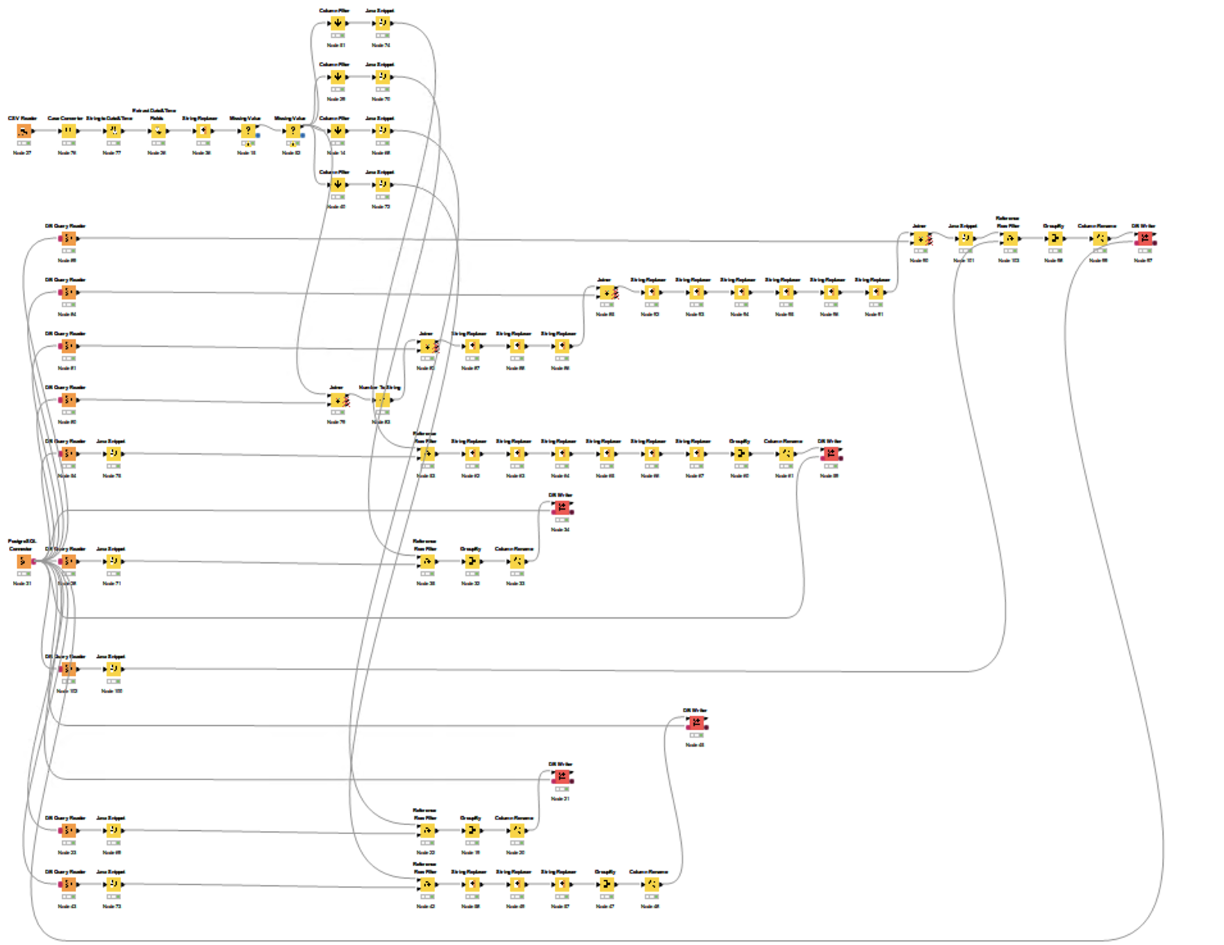

Figure: ETL Process flow for FEC election contribution

**Reading Input Excel Files:**

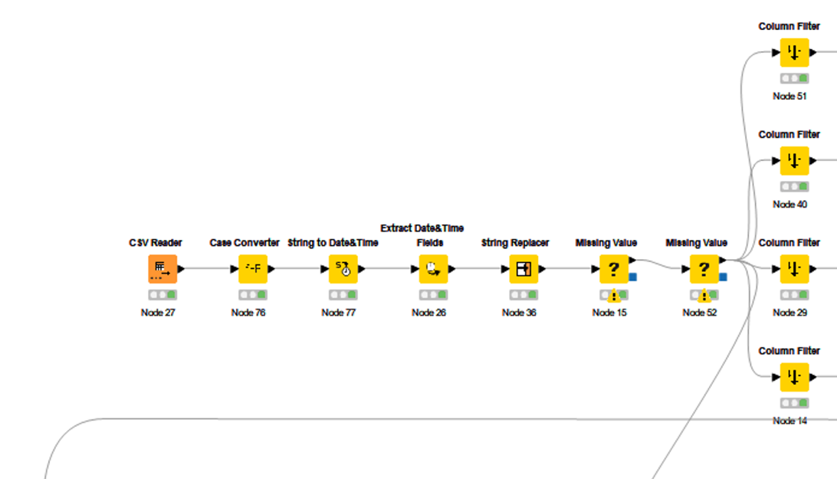

Reading data in KNIME is done using the CSV reader node. While there are multiple ways to read data, This node will be used because our data are in CSV files. This node loads each CSV file one after the other and stores the necessary data onto the dimension and fact tables.

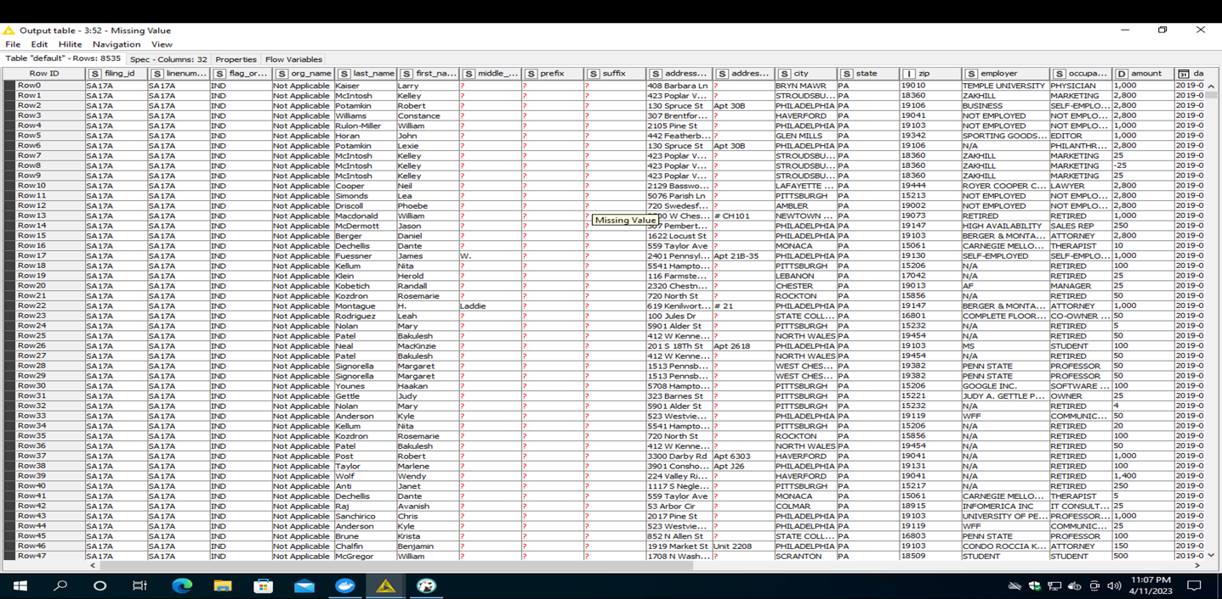

The following CSV talks about the contributions during Q1 2019 from PA and contains 8535 rows.

**Populating the Location Dimension:**

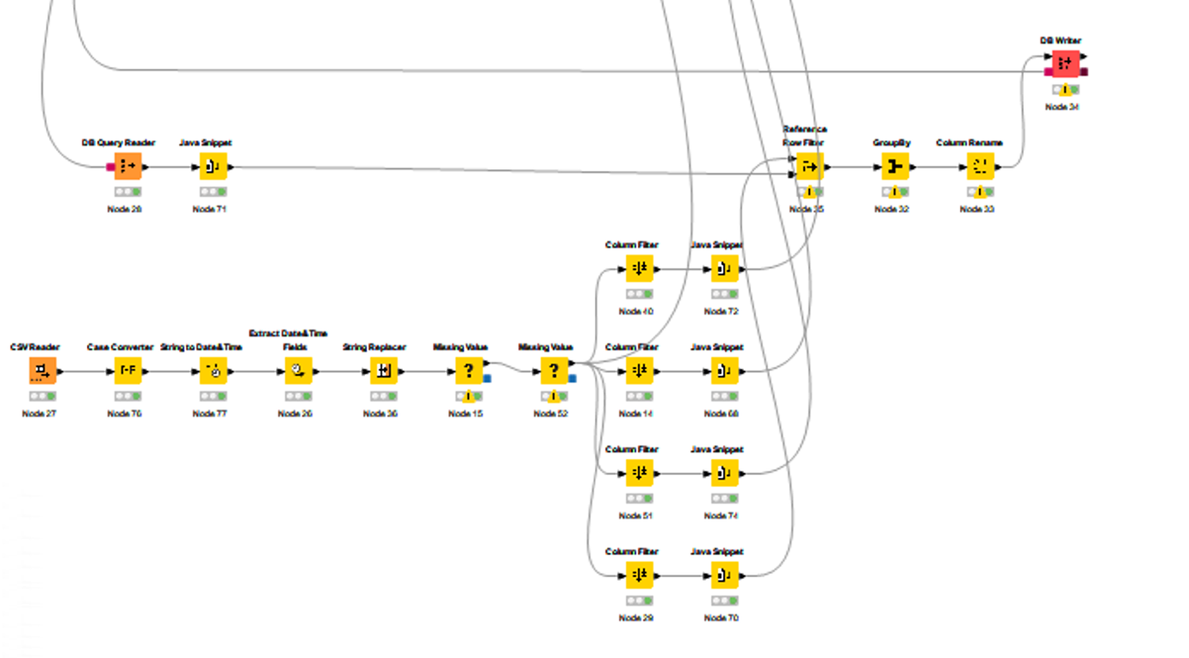

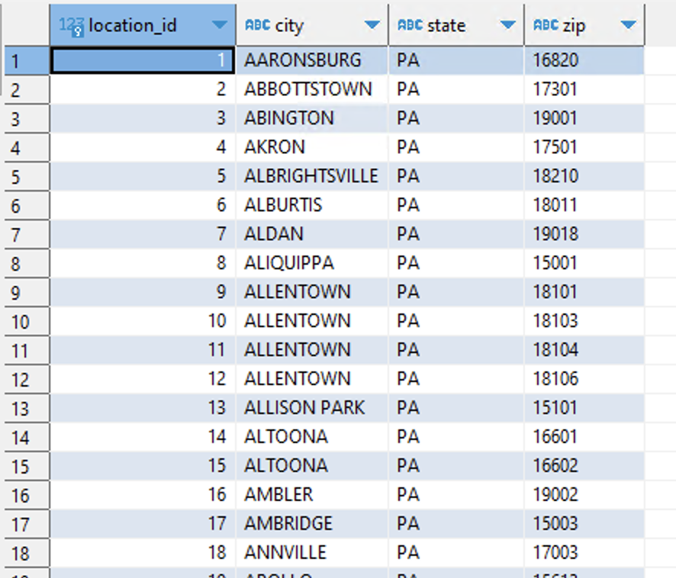

Since the data is loaded on CSV at a time, it can be seen the initial location values belong to PA.

**Populating the Date Dimension:**

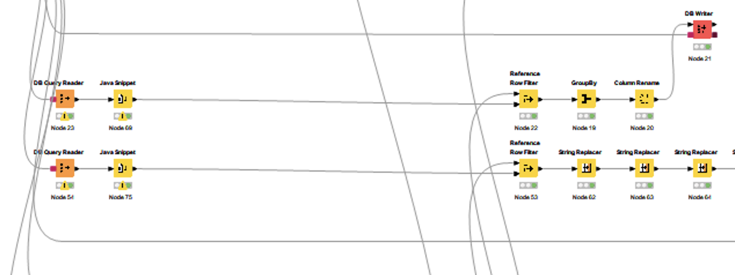

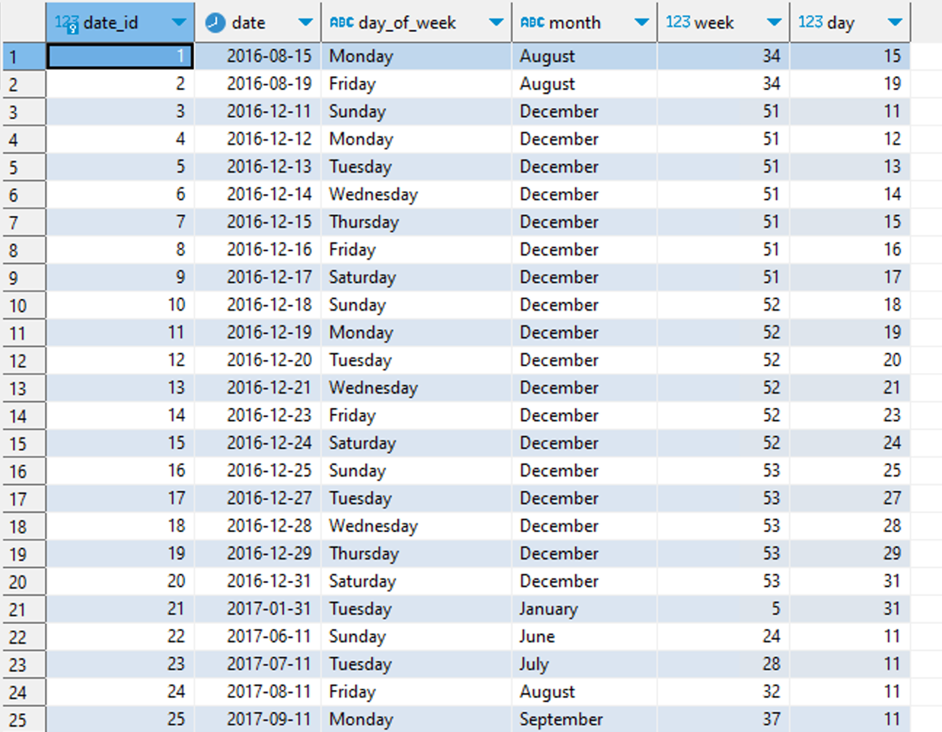

Since the data is loaded on CSV at a time, it can be seen the initial contribution values start all the way from 2016 for the state PA.

**Populating the Election Dimension:**

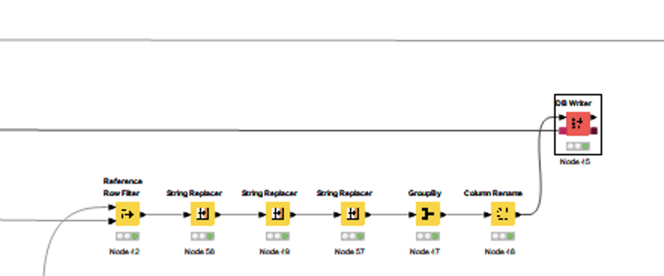

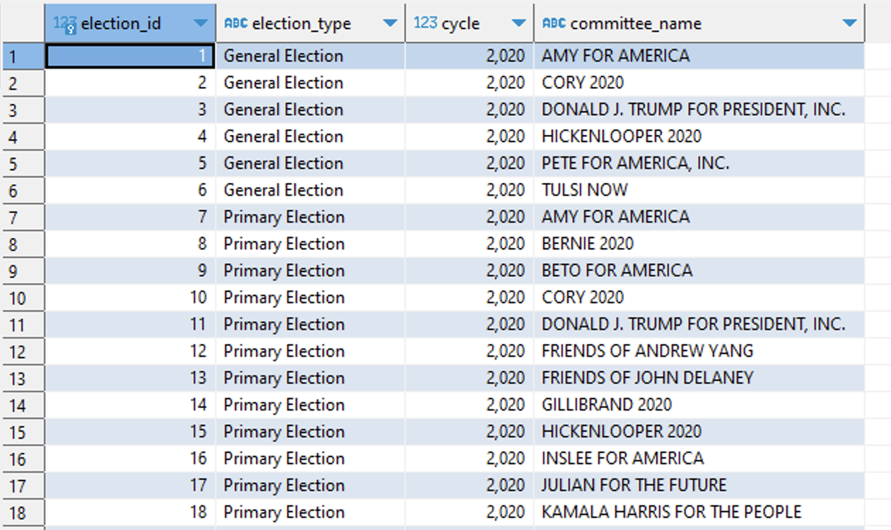

The above are the data points in the Dimension Election.

**Populating the Contributor Dimension:**

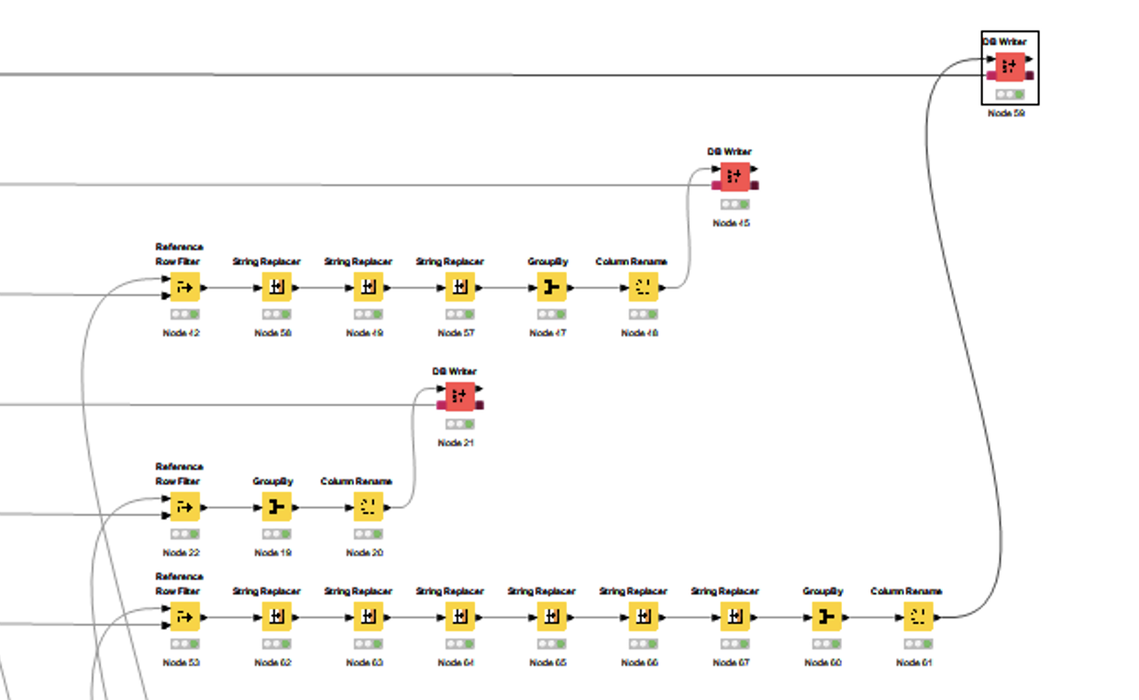

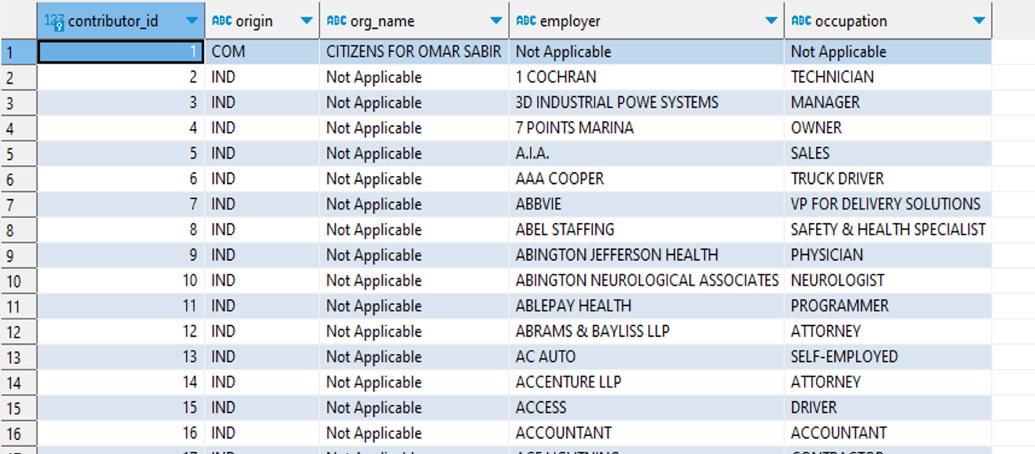

The above are the data points in the Dimension Contributor. Since there are multiple types of contributors (IND, COM, CCM, etc.). Null values for this table have been converted to Not Applicable as a flag, which will make it easier to query the Database for reporting.

**Populating the Fact Table:**

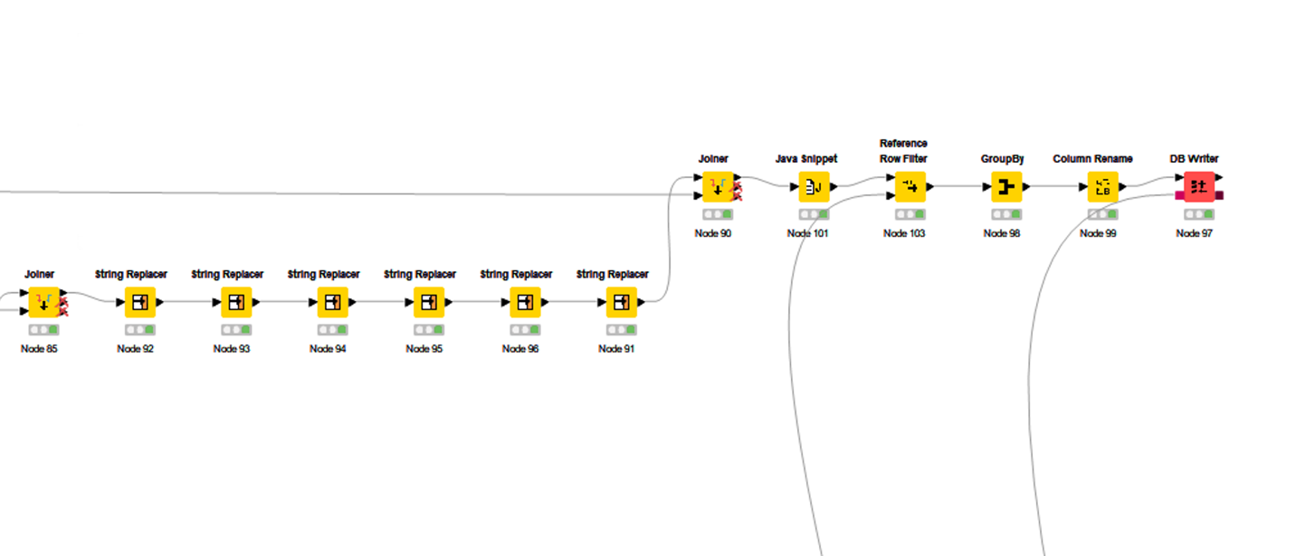

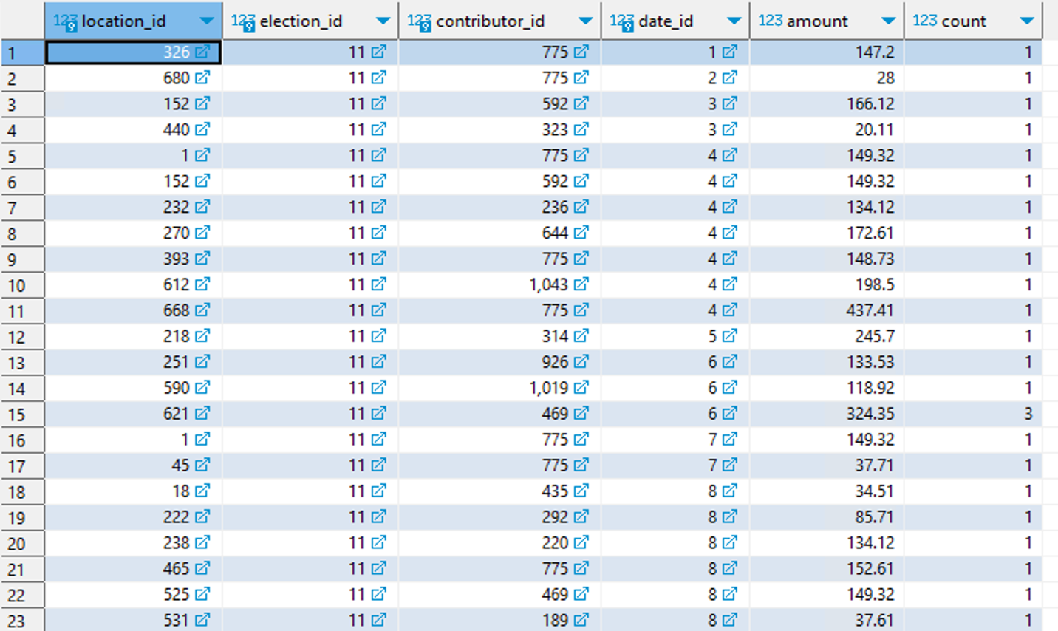

The fact table gets populated once the dimension tables are populated. The above fact table is aggregated at a daily level and the amount value is the sum for a combination of location_id, election_id, contributor_id and date_id. Duplicate values aren’t loaded into the database by checking row references.

**Data Count After populating the Fact Table:**

|  |  |  |
| --- | --- | --- |
| **Table Name** | **Total Rows** | **Total Columns** |
| Fact | 631,167 | 6 |
| Location | 6,471 | 4 |
| Date | 1,492 | 6 |
| Election | 94 | 4 |
| Contributor | 69,889 | 5 |

## 3.2 Hadoop Implementation

### Move Data from Local to Docker

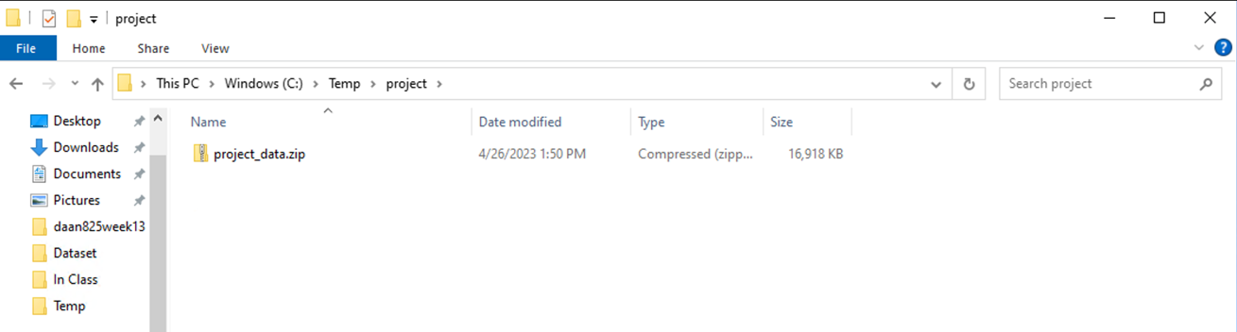

The first step in the implementation involves storing the csv files in a zipped folder in the local system. The files are then copied in a tmp folder in Docker container. The zipped folder is unzipped, and all the files can be viewed in the tmp folder of the container as mentioned below.

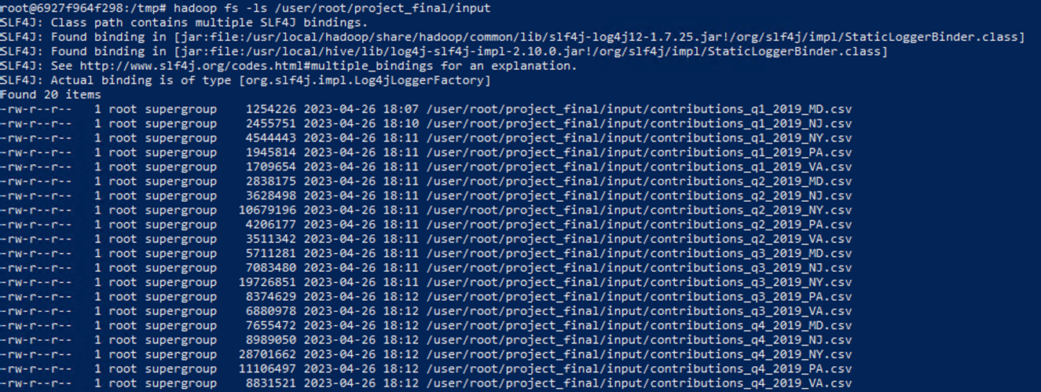

### PIG file to Transform Data

The following PIG file is used to read and clean the csv files. Initially all the attributes in the csv are taken as char array. These attributes are then trimmed down to the set of attributes that are necessary for the Hadoop schema.

The program then runs through each row to do the following tasks:

1. Convert amount into FLOAT.
2. Convert city names into lower case.
3. Convert year into INT.
4. Replace empty string in employer, occupation, org_name to ‘Not Applicable’ using regular expression.

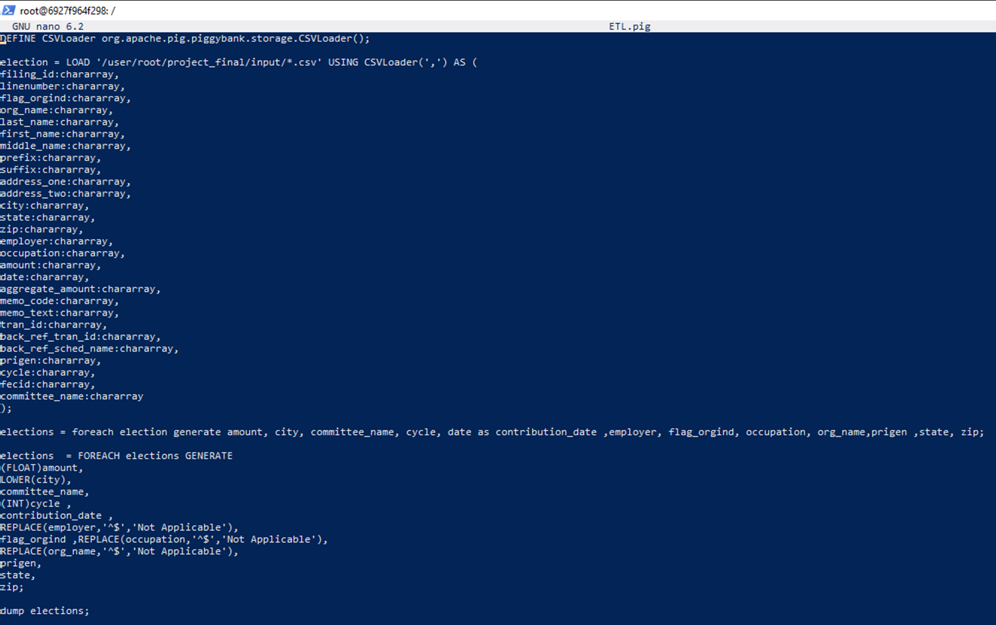

After pre-processing the data looks like the following:

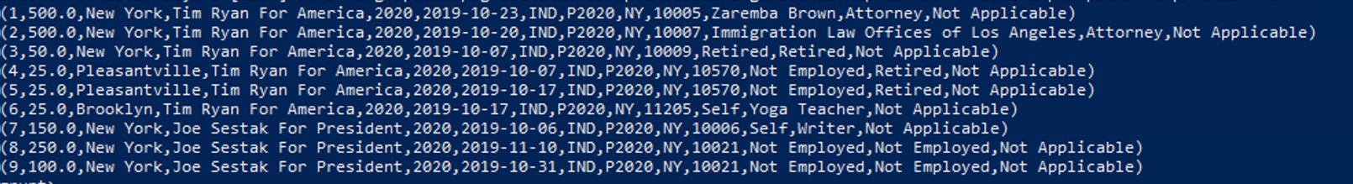

### Save Data to HDFS

Once we make sure that the data is in the right format, we can save it to the HDFS. It is important to keep in mind that the order in which the attributes are saved need to be in order with the schema created in HIVE.

The ‘@’ symbol will be used as the delimiter to save the data into HDFS. This symbol is used because there are no email ids in the columns that are required.

The data dump looks like the following with ‘@’ as the delimiter:

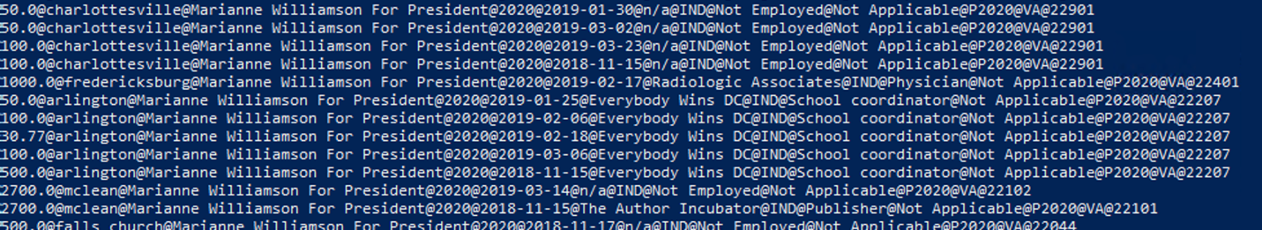

On loading the data into HDFS, we can see a total of 676,919 records are written which is shown below:

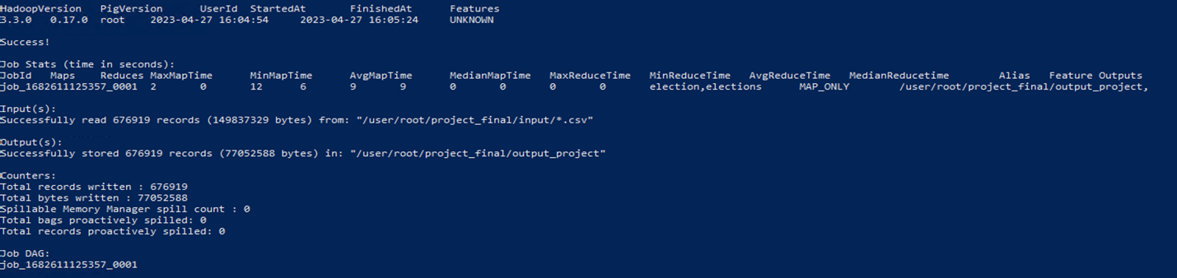

Once the data is loaded in HDFS, we can move it to the container and then upload it in the hive table.

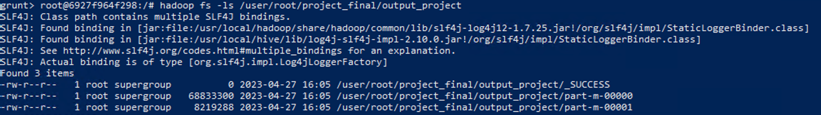

From the screenshot it can been seen that there are two output files that get created. Both files need to be pushed into the HIVE table. On querying the fact table in HIVE, a total of 676,919 rows are shown. This is equal to the count of records that were written by HDFS.

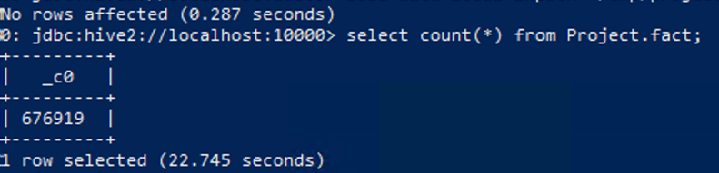

## 3.3 Reflective analysis of data preparation in relational data warehouse vs Hadoop.

**Data Warehouse**

KNIME is a powerful ETL tool for data preparation in a relational data warehouse. One of the benefits of using KNIME is that it offers a wide range of data processing nodes that can be easily dragged and dropped into a workflow to create custom data pipelines. This makes it quick and easy to extract data from various sources, make necessary transformation and then load it into a RDBMS.

Another advantage of using KNIME for data preparation is that it offers a range of data cleaning and preprocessing nodes that can help improve data quality.

There are some challenges as well when working with KNIME. Making changes to the relational database could require significant reworking of the workflow. This could be time-consuming process especially for large data sets. Another difficulty while using KNIME is that some of the more advanced nodes in KNIME required a certain level of technical expertise to use effectively.

**Hadoop**

Hadoop's approach to data preparation is different from traditional relational databases, which require the upfront definition of a schema before any data can be loaded. Instead, Hadoop's schema-on-read approach allows for the flexible interpretation of data during processing, making it easier to work with unstructured or semi-structured data.

The schema-on-read concept, coupled with the ability to load data into a single table, makes data preparation in Hadoop a relatively simple and quick process. Additionally, Hadoop can handle large datasets with varying characteristics, including volume, velocity, and variety, providing a scalable solution for big data management.

There are a few challenges when it comes to executing Data transformation using Map-Reduce or Pig language because of lack of interactivity in the console.

4. Reporting System

## 4.1 Relational Data Warehouse Implementation

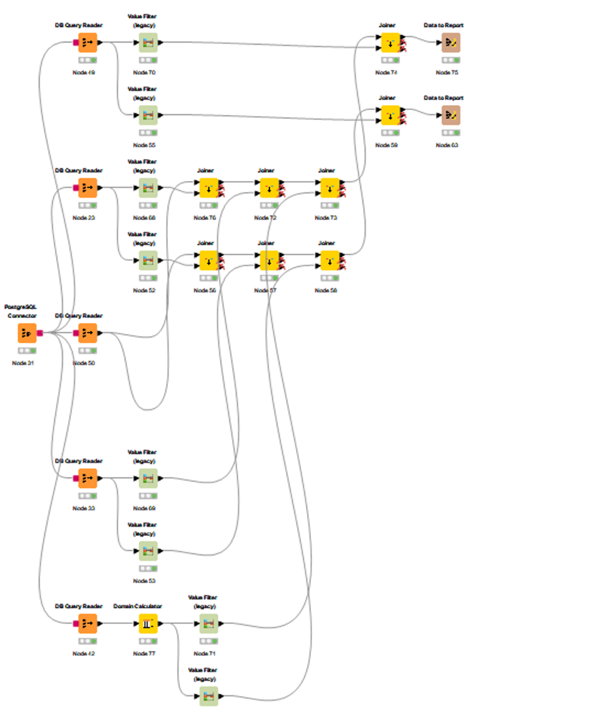

Figure: Data Reporting flow from PostgreSQL

The Report Builder in KNIME provides an interactive method to create charts, aggregates, and tables for analysis. The above diagram shows us how the dimension tables along with the fact table are read using DB Query reader. The tables are joined, grouped, and filtered based on the business requirements using the Joiner and Value Filter nodes. Then data is submitted to the Data to Report node, through which reports can generated and viewed.

**Business Questions**

1. Which Presidential committee received highest donations?

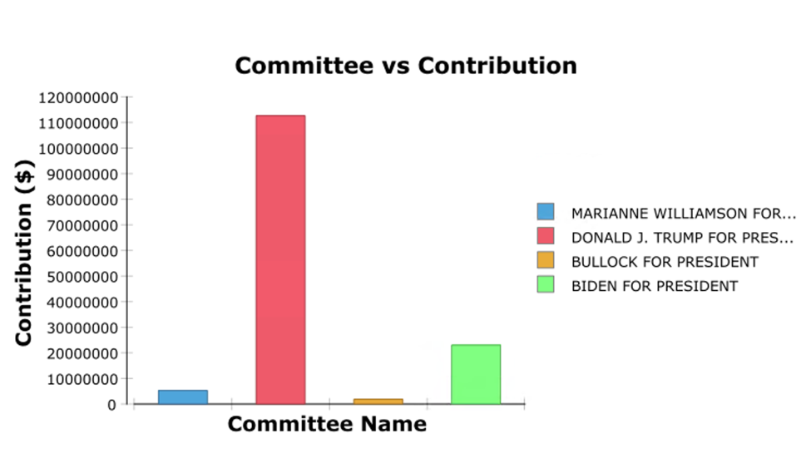

From the above bar chart, most of the contribution has been towards the committee “Donald J. Trump for President, Inc”. It can also be seen that the committee “Bullock for President” received the lease contribution because the states (NY, NJ, PA, VA, MD) even though these states are Pro-Biden.

1. What is the state-wise contribution towards the committee “Biden for President”?

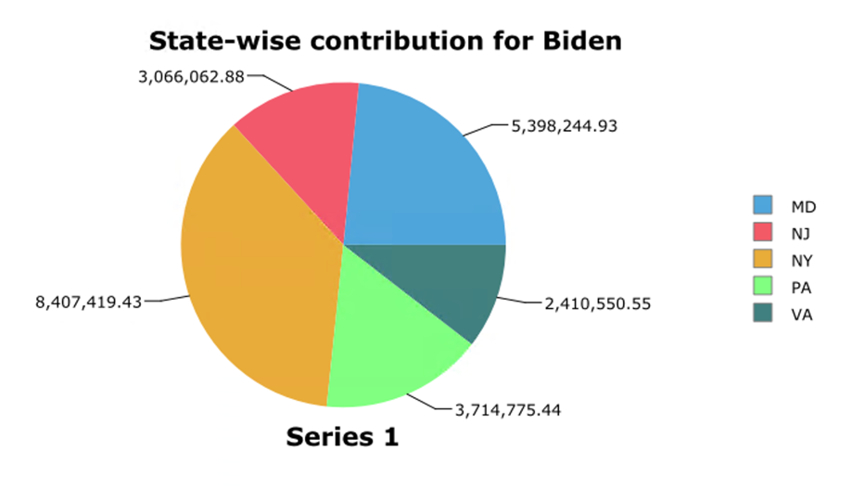

The following pie chart shows the state-wise contribution towards the committee "Biden for President". Most of the funding comes from the state NY and MD while VA contributes the least.

1. What is the average contribution by each type of contributor?

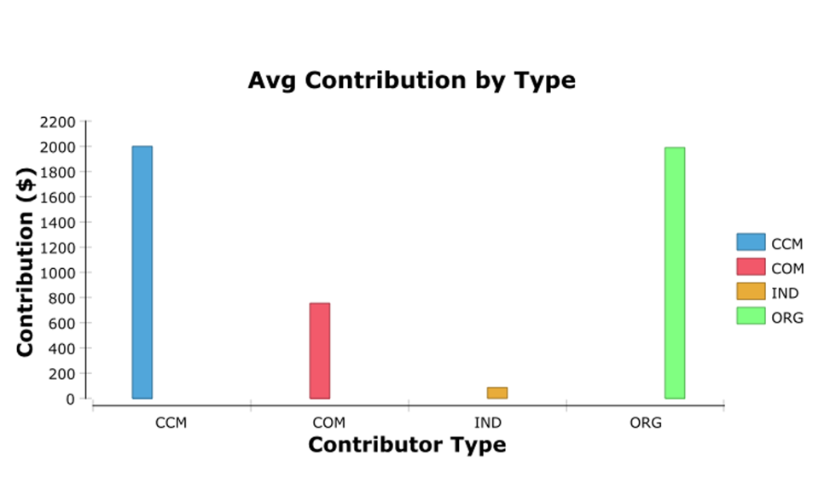

The above bar chart talks about the sources where the contributions origin from. From the chart it’s clear that most of the contributions come from CCM and ORG. It’s also clear that IND contribute the least towards political campaigns.

1. When can an increase in the amount of money contributed between NY and PA be seen?

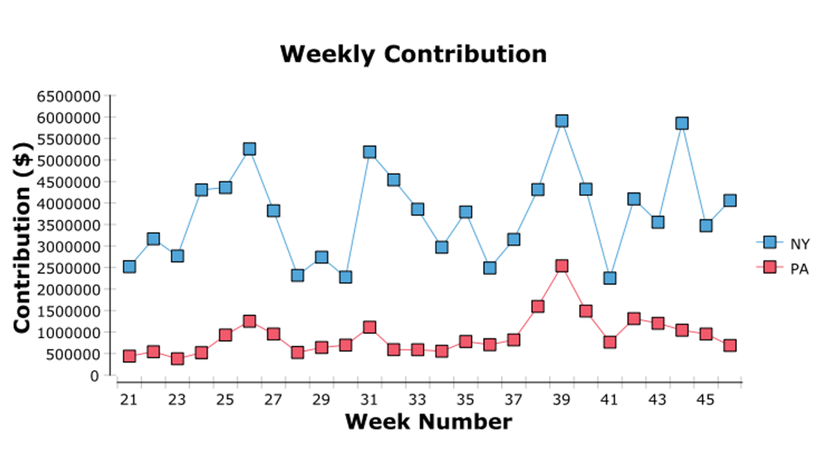

The line chart above shows the timeline in which the contributions were collected for the two states PA and NY. From this chart NY contributes more towards the presidential race as compared to PA. There is also a trend where most of the contributions happen past the 35th week in PA and it continues to increase till the election week. But this is not the case in NY as there has been a consistent trend in contributions throughout.

## 4.2 Hadoop Implementation

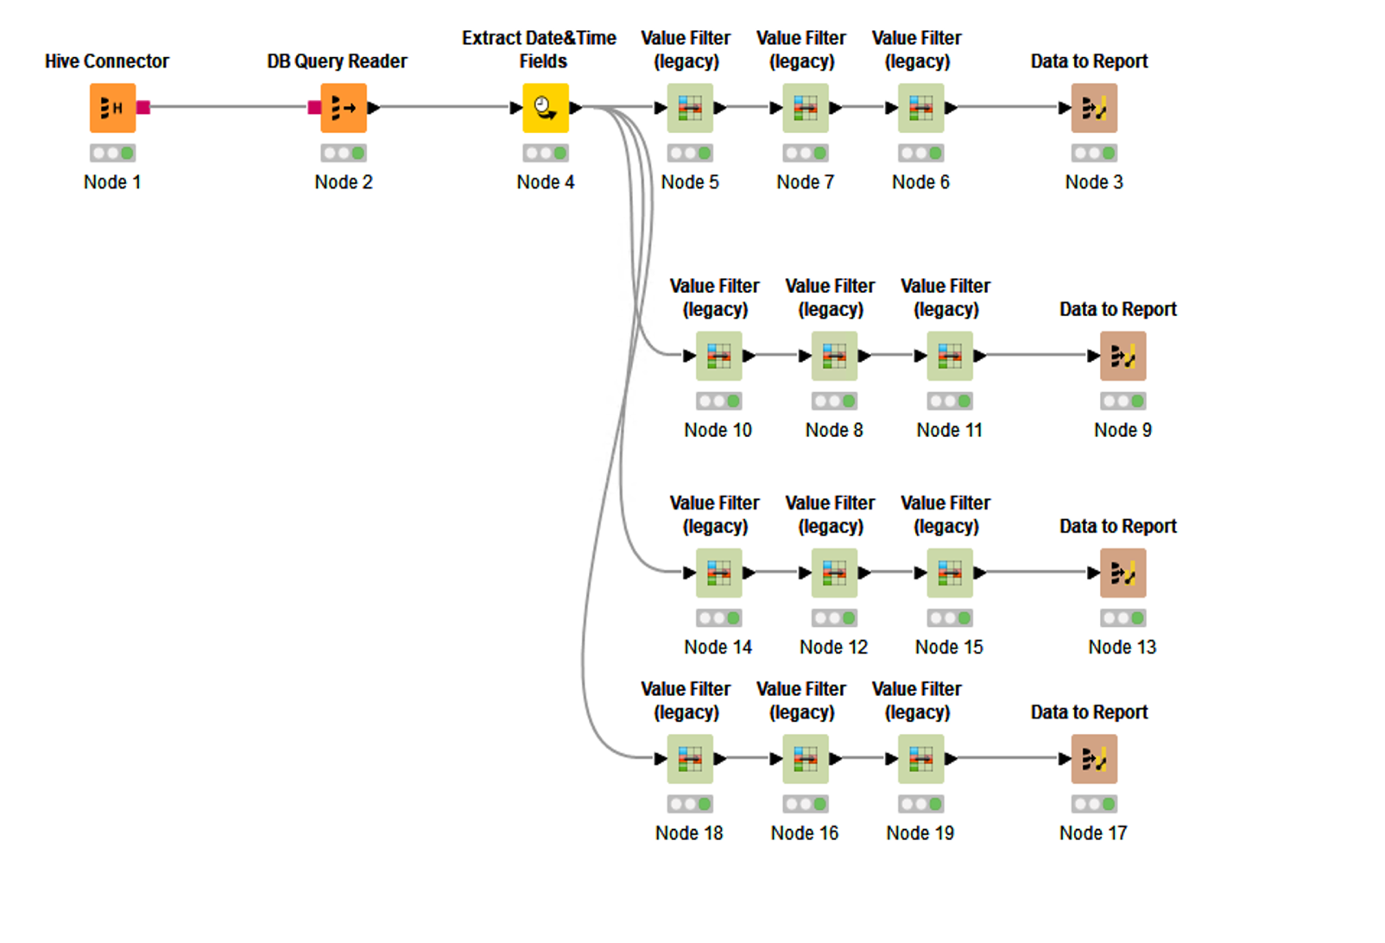

Figure: Data Reporting flow from Hive

The data in the HIVE table is read using the Hive connector node and the table is fact table is read using the DB Query reader. Extraction of day_of_week, week number, day has been done using the Extract Data&Time node in KNIME. Various Value filters are used to create filters before generating the report. This filtering process has been done to reduce the amount of data that goes into report making. The following filters have been used:

1. Committee_name filter
2. State filter
3. Election type filter
4. Contributor type filter
5. Org_name filter

**Business Questions**

1. Which Presidential committee received highest donations?

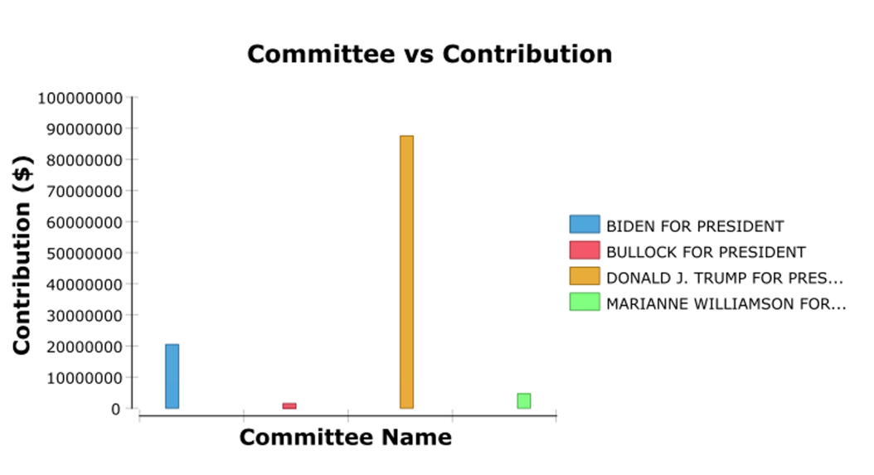

The above bar chart also shows a similar trend which was shown when the data was queried using PostgreSQL. Committee “Donald J. Trump for President, Inc” gets the maximum contribution while “Bullock for President” receives the least. But there is small difference in the scale of contribution between the two methods.

1. What is the state-wise contribution towards the committee “Biden for President”?

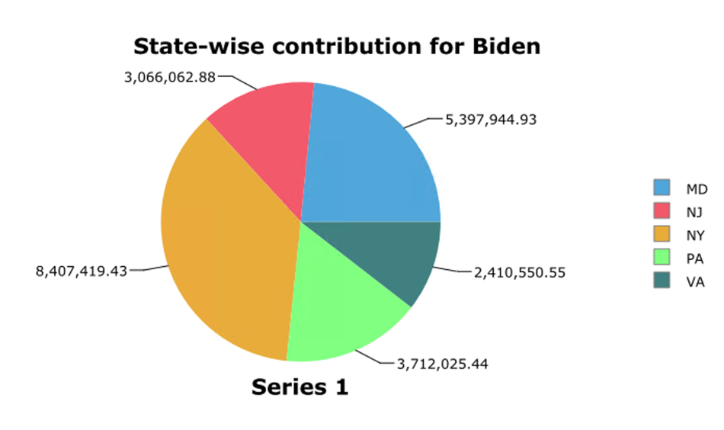

The above pie chart shows the state-wise contribution towards the committee "Biden for President". Like the previous methodology used, the inference remains the same that most of the funding comes from the state NY and MD while VA contributes the least. But there is a slight difference in the amount contributed from the states PA and MD.

1. What is the average contribution by each type of contributor?

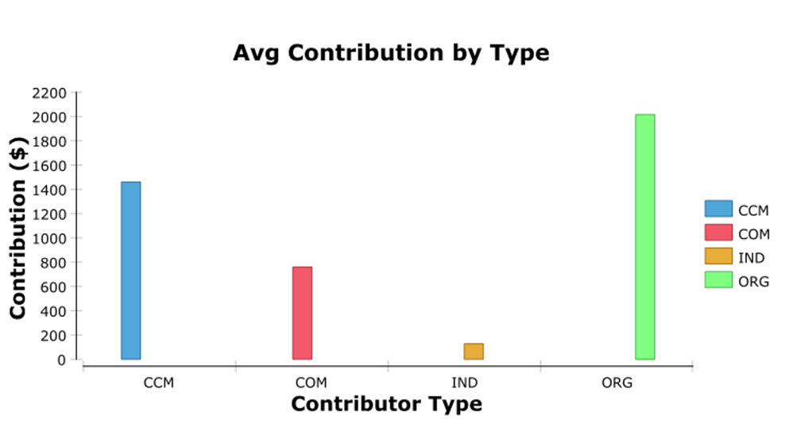

The above bar chart talks about the sources where the contributions origin from. Like the previous methodology, most of the contributions come from CCM and ORG while the IND contribute the least towards political campaigns. Here we observe a slight difference in the value donated by CCM.

1. When can an increase in the amount of money contributed between NY and PA be seen?

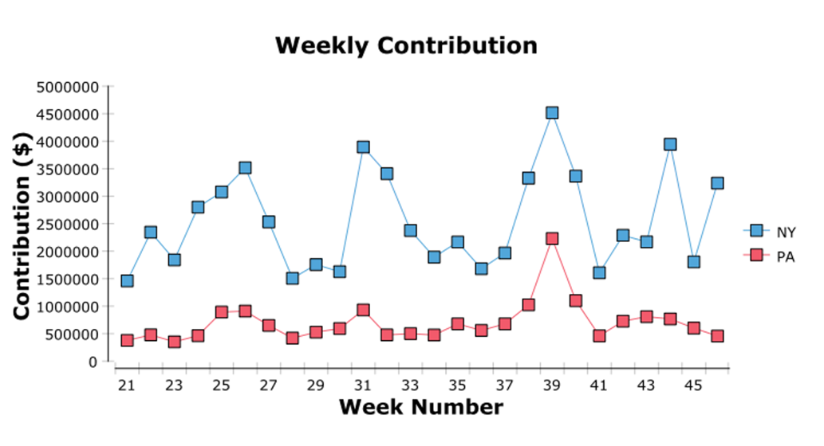

The line chart above shows a similar with the line chart which was plotted from the data from the Data Warehouse. This chart also shows the fact that NY contributes more as compared to PA. It also shows how the contribution peaks past the 35th week in PA and how it remains consistent in NY. But there is a difference in scale between the two approaches.

## 4.3 Reflective analysis of result in relational data warehouse vs Hadoop.

**Data Warehouse**

One of the key benefits of using KNIME for report preparation in relational data warehouses is its user-friendly interface. The graphical user interface (GUI) makes it easy to visualize the data and create visual representations of the data in the form of charts, graphs, and tables. This can be particularly useful for creating reports that are easily understood by non-technical stakeholders.

Another advantage of using KNIME is that it offers a wide range of data processing and analysis tools. These tools can be used to perform complex calculations, filtering, and aggregation on the data, allowing users to gain insights into the data and identify trends and patterns. This can be particularly useful for creating reports that provide valuable insights and recommendations for decision-makers.

**Hadoop**

Using the Hive connector in KNIME to analyze data stored in Hadoop can be a powerful and efficient way to gain insights from large and complex datasets. The integration of Hadoop with KNIME allows for seamless data processing and analysis, leveraging the power of distributed computing and the flexibility of Hive's SQL-like interface.

One benefit of using Hive in KNIME is the ability to easily query and analyze data stored in Hadoop, without the need for complex ETL processes.

However, the use of Hadoop and Hive in KNIME does require some technical expertise, particularly in setting up and configuring the Hadoop cluster and Hive environment.

As observed in the reports attached above, there are certain differences in the count and scale even though the reports generated for the same data and business query. This difference could be because both the approaches used different methods to clean and transform the data. While most of the transformation in the Data warehouse were through KNIME, Hadoop used Pig to transform the data. The difference in reports that were generated were also due to filtering of different rows and columns based on the different data pre-processing steps performed. Also, Datawarehouse processing is based on schema-on-write concepts; whereas Hadoop processing is based on schema-on-read concepts.

Conclusions

**Advantages of Data Warehouse Implementation:**

1. Performs well regardless the size of the dataset.
2. Has better security features.
3. Using KNIME for ETL helps understand possible Data quality issues.

**Disadvantages of Data Warehouse Implementation:**

1. Designing the Warehouse is a time-consuming process.
2. Cost of implementation increases with size of the database.

**Advantages of Hadoop Implementation:**

1. Hadoops Schema-on-read approach.
2. Hadoop is cost effect because it’s open source.
3. Hadoop allows for easy scaling.

**Disadvantages of Hadoop Implementation:**

1. Constructing Map Reduce programs can be complex.
2. Hadoop can pose security challenges when handling sensitive data.